ADITYA UNIVERSITY
Surampalem
Department of AIML
DBMS CAPSTONE PROJECT
Project Documentation Report
Project Title: Hospital Management System
Submitted by:
S.No | Student Name | Roll Number
1 | K. Jishmitha | 25B11AI467
2 | P. Ramya Sri | 25B11AI878
3 | K. Sirisha | 25B11AIB40
4 | U. Sowjanya | 25B11AIC19
Course: Database Management Systems (DBMS) Course Code: ____________
Faculty Coordinator: Mrs. V.G.L. Narasamba
Academic Year: 2nd year 2026 Date of Submission: __________
GitHub Repository Link:
https://github.com/jishmitha31-hash/hospital-management-system.
https://github.com/ramyasripalati/Hospital-Management-System
https://github.com/Sirisha-kunduri/Hospital-Management--system
https://github.com/udathasowjanya/Hospital-management-system

TABLE OF CONTENTS
(This table updates automatically when the document is opened in Microsoft Word. If it appears empty, right-click it and choose "Update Field".)
TABLE OF CONTENTS 1
1. ABSTRACT 1
2. INTRODUCTION 1
2.1 Background 1
2.2 Purpose of the Database 1
3. PROBLEM STATEMENT 1
4. OBJECTIVES 1
5. TOOLS & TECHNOLOGIES USED 1
6. DATABASE DESIGN 1
6.1 Identified Entities 1
6.2 Entity Attributes 1
6.3 ER Diagram 1
6.4 Relationships & Cardinality 1
6.5 Relational Database Schema 1
6.6 Normalization 1
7. DATABASE IMPLEMENTATION 1
7.1 DDL — Database and Table Creation 1
7.2 Sample Data — DML 1
7.3 Constraints & Data Integrity 1
7.4 SQL Operations & Queries 1
7.5 Sample Outputs / Screenshots 1
8. MODULES & FUNCTIONALITIES 1
9. GITHUB REPOSITORY & TEAM RESPONSIBILITIES 1
10. ENHANCEMENTS & FUTURE IMPROVEMENTS 1
11. CONCLUSION 1
12. REFERENCES 1
APPENDIX 1
A. Complete SQL Script 1
B. Additional Screenshots / Outputs 1

1. ABSTRACT
The Hospital Management System project focuses on designing a normalized relational database to support core hospital operations. Hospitals routinely handle large volumes of sensitive data — patient records, doctor schedules, appointments, treatments, and billing — often across manual registers or disconnected spreadsheets, which leads to duplicate records, slow retrieval of patient history, scheduling conflicts, and billing errors that directly affect patient care quality. This project identifies eight core entities — Patient, Doctor, Department, Appointment, Medical Record, Billing, Room, and Staff — and defines precise attributes for each. A complete ER diagram captures the relationships and cardinalities between these entities, which is then translated into a relational schema with well-defined tables and columns. Primary Key and Foreign Key constraints are enforced across all eight tables to maintain referential integrity. The resulting database enables fast, accurate retrieval of patient history, appointments, and billing records, and significantly improves the overall efficiency of hospital operations and patient care.

2. INTRODUCTION

2.1 Background
Hospitals handle large volumes of sensitive data — patient records, doctor schedules, appointments, treatments, and billing — often across manual registers or disconnected spreadsheets. This leads to duplicate records, slow retrieval of patient history, scheduling conflicts, and billing errors — directly affecting patient care quality. A centralized, well-structured relational database is needed to store, relate, and retrieve hospital data reliably and efficiently.

2.2 Purpose of the Database
A centralized, well-structured relational database is needed to store, relate, and retrieve hospital data reliably and efficiently. It is used by hospital staff to manage patient records, doctor schedules, appointments, medical records, billing, and room allocation, enabling fast, accurate retrieval of patient history, appointments, and billing records.

3. PROBLEM STATEMENT
Hospitals handle large volumes of sensitive data — patient records, doctor schedules, appointments, treatments, and billing — often across manual registers or disconnected spreadsheets. This leads to duplicate records, slow retrieval of patient history, scheduling conflicts, and billing errors — directly affecting patient care quality. Specific limitations include Fragmented Records (patient history scattered across departments and paper files), Scheduling Conflicts (no unified view of doctor and room availability), and Billing Errors (manual invoicing causes mismatches and delays). A centralized, well-structured relational database is needed to store, relate, and retrieve hospital data reliably and efficiently, addressing these problems.

4. OBJECTIVES
List 3–5 clear and measurable objectives.
- Objective 1: Design a normalized relational database that models core hospital operations end-to-end.
- Objective 2: Identify key entities (Patient, Doctor, Department, etc.) and define precise attributes for each.
- Objective 3: Build a clear ER diagram capturing relationships and cardinalities between entities.
- Objective 4: Translate the ER model into a relational schema with well-defined tables and columns.
- Objective 5: Enforce data integrity through Primary Key and Foreign Key constraints.
- Objective 6: Enable fast, accurate retrieval of patient history, appointments, and billing records.

5. TOOLS & TECHNOLOGIES USED
List the DBMS software, IDE/client tool, and any front-end or scripting technology used to build and demonstrate the project.
Category | Tool / Technology Used
Database Server | MySQL or PostgreSQL — planned
Query / Admin Tool | To be finalized by the team
Front-end (if any) | To be finalized by the team
Operating System | To be finalized by the team
Version Control | GitHub

6. DATABASE DESIGN

6.1 Identified Entities
Minimum: 6 entities. Provide a short description of each entity.
S.No | Entity Name | Description
1 | Patient | Individuals receiving medical care
2 | Doctor | Medical professionals providing treatment
3 | Department | Hospital divisions, e.g. Cardiology
4 | Appointment | Scheduled patient–doctor visits
5 | Medical Record | Diagnosis and treatment history
6 | Billing | Payments and invoice details
7 | Room | Ward / room allocation for patients
8 | Staff | Nurses and support personnel

6.2 Entity Attributes
List the attributes of each entity. Mark Primary Keys (PK) and Foreign Keys (FK).
Entity | Main Attributes | PK / FK | Key (PK/FK/—) | Attribute Type
Patient | PatientID, FirstName, LastName, DOB, Gender, Phone, Address, BloodGroup | PK: PatientID | Patient id-PK | SIMPLE  (all attributes)
Doctor | DoctorID, FirstName, LastName, Specialization, Phone, Email, DepartmentID | PK: DoctorID; FK: DepartmentID | DoctorID -PK  Department-FK | SIMPLE  (all attributes)
Department | DepartmentID, DeptName, Location, HeadDoctorID | PK: DepartmentID; FK: HeadDoctorID | DepartmentID-PK  Headdoctor-FK | SIMPLE  (all attributes)
Appointment | AppointmentID, PatientID, DoctorID, ApptDate, ApptTime, Status | PK: AppointmentID; FK: PatientID, DoctorID | AppointmentID-PK  PatientID-fk  DoctorID-FK | SIMPLE  (all attributes)
Medical Record | RecordID, PatientID, DoctorID, Diagnosis, Treatment, RecordDate | PK: RecordID; FK: PatientID, DoctorID | RecordID-PK  PatientID-FK  DoctorID-FK | SIMPLE  (all attributes)
Billing | BillID, PatientID, AppointmentID, Amount, PaymentStatus, BillDate | PK: BillID; FK: PatientID, AppointmentID | Bulid-PK  PatientID-FK  Appointment-FK | SIMPLE  (all attributes)
Room | RoomID, RoomType, Status, DepartmentID, PatientID | PK: RoomID; FK: DepartmentID, PatientID | RoomID-PK  DepartmentID-FK | SIMPLE  (all attributes)
Staff | StaffID, Name, Role, Phone, DepartmentID | PK: StaffID; FK: DepartmentID | Staff-PK  DepartmentID-FK | SIMPLE  (all attributes)
Attribute Type: Simple / Composite / Multi-valued / Derived
6.3 ER Diagram
Insert the complete ER diagram showing entities, attributes, relationships, and cardinalities.
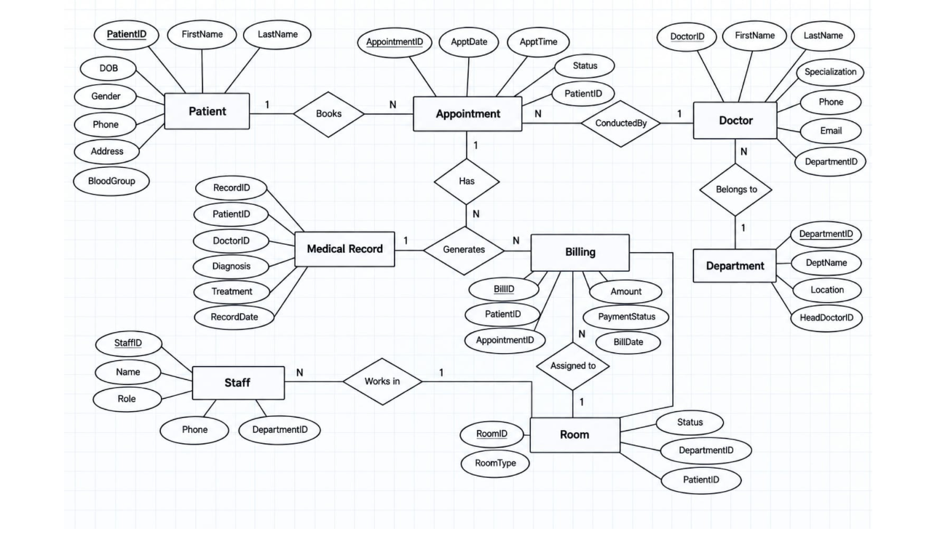

6.4 Relationships & Cardinality
Entity 1 | Relationship | Entity 2 | Cardinality (1:1 / 1:N / M:N)
Patient | BOOKS | Appointment | 1:N
Patient | BELONGS TO | Department | N:1
Appointment | GENERATES | Medical Record | 1:N
Appointment | WITH | Doctor | N:1
Doctor | WORKS IN | Department | N:1
Medical Record | GENERATES | Billing | 1:N
Staff | ASSIGNED TO | Billing | N:1
Billing | CHARGED FOR | Room | N:1

6.5 Relational Database Schema
List every table, its columns, data types, and identify PK/FK columns.
Table Name | Column Name | Data Type | PK/FK/— | Constraints
Patient | PatientID | INT | PK | PRIMARY KEY, NOT NULL
Patient | FirstName | VARCHAR(50) | - | NOT NULL
Patient | LastName | VARCHAR(50) | - | NOT NULL
Patient | DOB | DATE | -
Patient | Gender | VARCHAR(50) | -
Patient | Phone |  | -
Patient | Address | VARCHAR(150) | -
Patient | BloodGroup | VARCHAR(5) | -
Doctor | DoctorID | INT | PK | PRIMARY KEY, NOT NULL
Doctor | FirstName | VARCHAR(50) | - | NOT NULL
Doctor | LastName | VARCHAR(50) | - | NOT NULL
Doctor | Specialization | VARCHAR(100) | -
Doctor | Phone |  | -
Doctor | Email | VARCHAR(50) | - | UNIQUE
Doctor | DepartmentID | INT | FK | References Department(DepartmentID)
Department | DepartmentID | INT | PK
Department | DeptName | VARCHAR(50) | -
Department | Location | VARCHAR(100) | -
Department | HeadDoctorID | INT | FK | References Doctor(DoctorID)
Appointment | AppointmentID | INT | PK | PRIMARY KEY, NOT NULL
Appointment | PatientID | INT | FK | References Patient(PatientID)
Appointment | DoctorID | INT | FK | References Doctor(DoctorID)
Appointment | ApptDate | DATE | - | NOT NULL
Appointment | ApptTime | TIME | - | NOT NULL
Appointment | Status | VARCHAR(50) | - | DEFAULT’Scheduled’
Medical Record | RecordID | INT | PK | PRIMARY KEY, NOT NULL
Medical Record | PatientID | INT | FK | References Patient(PatientID)
Medical Record | DoctorID | INT | FK | References Doctor(DoctorID)
Medical Record | Diagnosis | VARCHAR(250) | -
Medical Record | Treatment | VARCHAR(250) | -
Medical Record | RecordDate | DATE | - | NOT NULL
Billing | BillID | INT | PK | PRIMARY KEY, NOT NULL
Billing | PatientID | INT | FK | References Patient(PatientID)
Billing | AppointmentID | INT | FK | References Appointment(AppointmentID)
Billing | Amount | DECIMAL(10,2) | - | CHECK(Amount>=0)
Billing | PaymentStatus | VARCHAR(50) | - | DEFAULT’Pending’
Billing | BillDate | DATE | - | NOT NULL
Room | RoomID | INT | PK | PRIMARY KEY, NOT NULL
Room | RoomType | VARCHAR(50) | -
Room | Status | VARCHAR(50) | - | DEFAULT’Available’
Room | DepartmentID | INT | FK | References Department(DepartmentID)
Room | PatientID | INT | FK | References Patient(PatientID)
Staff | StaffID | INT | PK | PRIMARY KEY, NOT NULL
Staff | Name | VARCHAR(50) | - | NOT NULL
Staff | Role | VARCHAR(50) | -
Staff | Phone |  | -
Staff | DepartmentID | INT | FK | References Department(DepartmentID)

6.6 Normalization
Explain how redundancy and update anomalies were reduced. Show the normalization process up to 3NF where applicable.
UNF → 1NF → 2NF → 3NF

7. DATABASE IMPLEMENTATION

7.1 DDL — Database and Table Creation
Paste CREATE DATABASE / CREATE TABLE statements and include constraints such as NOT NULL, UNIQUE, CHECK, DEFAULT, PRIMARY KEY, and FOREIGN KEY.
CREATE DATABASE HospitalManagementSystem;
USE HospitalManagementSystem;

CREATE TABLE Patient (
PatientID INT PRIMARY KEY,
FirstName VARCHAR(50) NOT NULL,
LastName VARCHAR(50) NOT NULL,
Phone VARCHAR(15),
BloodGroup VARCHAR(5)
);

CREATE TABLE Department (
DepartmentID INT PRIMARY KEY,
DeptName VARCHAR(50) NOT NULL,
Location VARCHAR(100)
);

CREATE TABLE Doctor (
DoctorID INT PRIMARY KEY,
FirstName VARCHAR(50) NOT NULL,
Specialization VARCHAR(100),
DepartmentID INT,
FOREIGN KEY (DepartmentID)
REFERENCES Department(DepartmentID)
);

CREATE TABLE Appointment (
AppointmentID INT PRIMARY KEY,
PatientID INT,
DoctorID INT,
ApptDate DATE,
Status VARCHAR(30) DEFAULT 'Scheduled',
FOREIGN KEY (PatientID) REFERENCES Patient(PatientID),
FOREIGN KEY (DoctorID) REFERENCES Doctor(DoctorID)
);

CREATE TABLE MedicalRecord (
RecordID INT PRIMARY KEY,
PatientID INT,
Diagnosis VARCHAR(200),
Treatment VARCHAR(200),
FOREIGN KEY (PatientID) REFERENCES Patient(PatientID)
);

CREATE TABLE Billing (
BillID INT PRIMARY KEY,
PatientID INT,
Amount DECIMAL(10,2) CHECK (Amount >= 0),
PaymentStatus VARCHAR(30) DEFAULT 'Pending',
FOREIGN KEY (PatientID) REFERENCES Patient(PatientID)
);

CREATE TABLE Room (
RoomID INT PRIMARY KEY,
RoomType VARCHAR(50),
Status VARCHAR(30) DEFAULT 'Available'
);

CREATE TABLE Staff (
StaffID INT PRIMARY KEY,
Name VARCHAR(50),
Role VARCHAR(50),
DepartmentID INT,
FOREIGN KEY (DepartmentID)
REFERENCES Department(DepartmentID)
);

7.2 Sample Data — DML
Insert sufficient sample data into all tables. Include INSERT, UPDATE, and DELETE examples where applicable.
Table | No. of Records | Sample Data / Screenshot Reference
Patient | To be populated | Add INSERT output
Doctor | To be populated | Add INSERT output
Department | To be populated | Add INSERT output
Appointment | To be populated | Add INSERT output
MedicalRecord | To be populated | Add INSERT output
Billing | To be populated | Add INSERT output
Room | To be populated | Add INSERT output
Staff | To be populated | Add INSERT output

7.3 Constraints & Data Integrity
List the constraints and validations applied to keep the data accurate and consistent (no duplicate IDs, valid values, referential integrity).
Constraint / Validation | Applied On | Purpose | Evidence / Screenshot
Primary Key | All eight entities | Prevents duplicate IDs | To be added
Foreign Key | Related tables | Maintains referential integrity | To be added
NOT NULL | Mandatory fields | Prevents missing required values | To be added
UNIQUE | Identifiers / selected fields | Prevents duplicate values | To be added
CHECK | Status and amount fields | Restricts invalid values | To be added
DEFAULT | Suitable status/date fields | Provides default values | To be added

7.4 SQL Operations & Queries
Include representative examples of DDL, DML, DQL, CRUD, Joins, Aggregate Functions, GROUP BY / HAVING, Subqueries, Views, and other relevant queries.
S.No | Operation / Query | Purpose | SQL Query / Screenshot Ref.
1 | CREATE TABLE | Create structured tables | Add final DDL
2 | INSERT | Add sample records | Add final DML
3 | SELECT | Retrieve records | Add SELECT output
4 | JOIN | Combine related tables | Add JOIN output
5 | Aggregate | Summarize bills or appointments | Add COUNT/SUM output
6 | GROUP BY / HAVING | Generate summaries | Add output
7 | UPDATE / DELETE | Modify or remove records | Add DML output
8 | VIEW / Subquery | Create reusable reports or filtered results | Add output

7.5 Sample Outputs / Screenshots
Paste important execution screenshots with a short caption. Screenshots should clearly show the query and its output.
Figure 1:
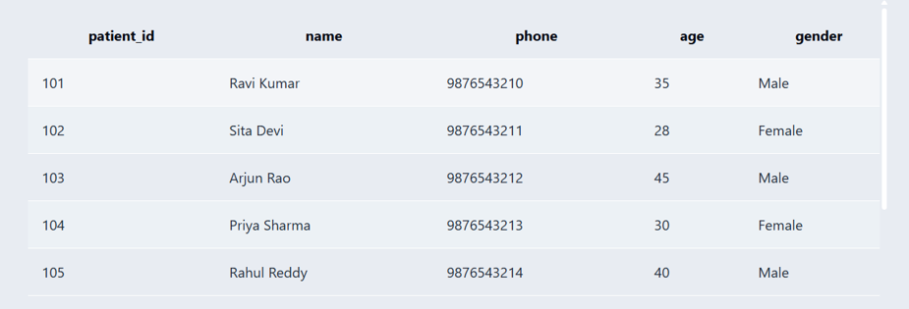

Figure 2:
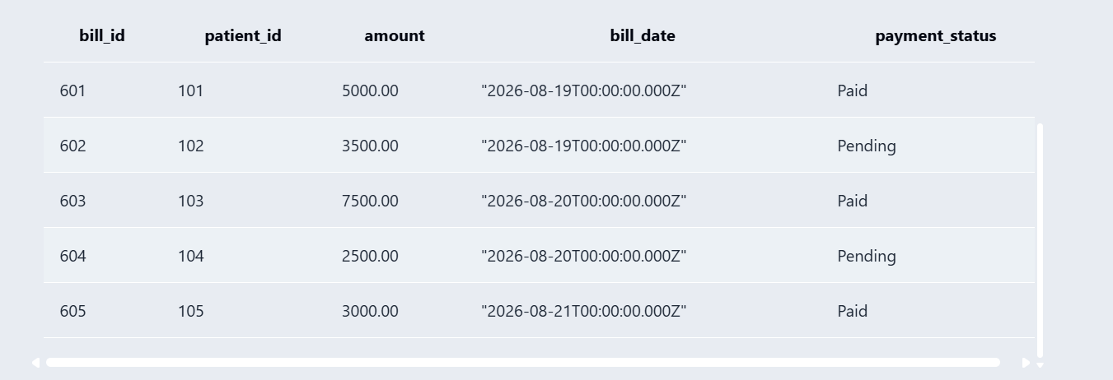

Figure 3:
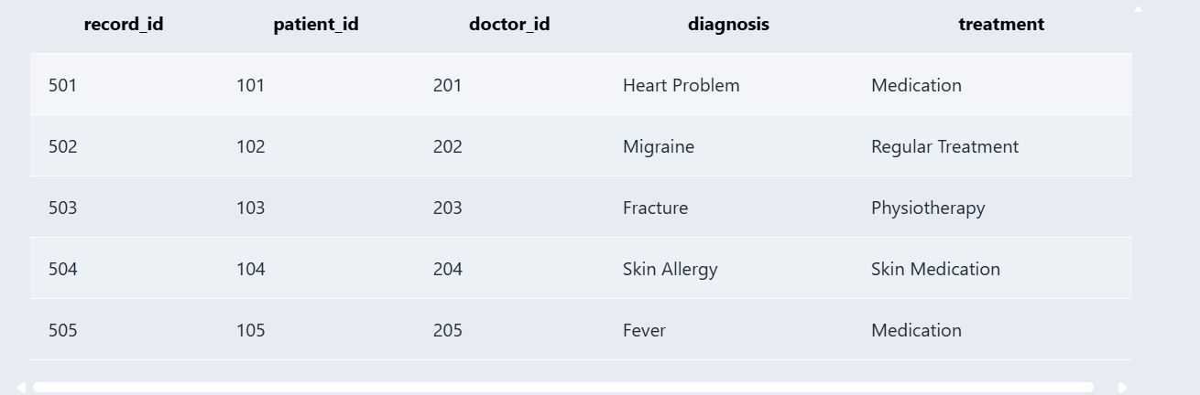
Figure 4:
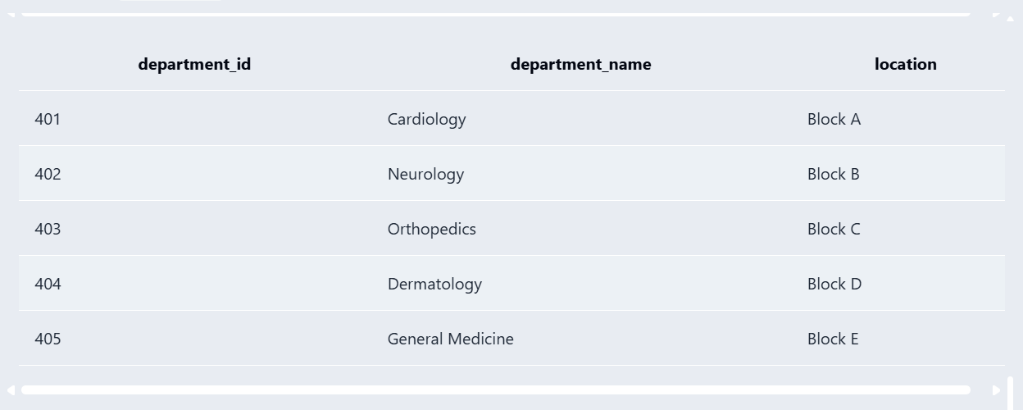

8. MODULES & FUNCTIONALITIES
Explain the major modules/features of the system and what each module does.
S.No | Module Name | Functionality
S.No | Module Name | Functionality
1 | Patient Management | Stores and retrieves patient profile information.
2 | Doctor and Department Management | Maintains doctor specialization and department details.
3 | Appointment Management | Records patient–doctor visits, dates, times, and status.
4 | Medical Records | Stores diagnosis, treatment, doctor, patient, and record date.
5 | Billing and Payments | Maintains bills, amounts, payment status, and bill dates.
6 | Room Allocation | Tracks room type, status, department, and patient allocation.
7 | Staff Management | Maintains staff names, roles, phone numbers, and departments.

9. GITHUB REPOSITORY & TEAM RESPONSIBILITIES
Provide the repository link and clearly mention each team member's contribution.
Repository Link:
https://github.com/jishmitha31-hash/hospital-management-system.
https://github.com/ramyasripalati/Hospital-Management-System
https://github.com/Sirisha-kunduri/Hospital-Management--system
https://github.com/udathasowjanya/Hospital-management-system

Student Name | Roll Number | Role / Responsibility | Contribution Status
K. Jishmitha | 25B11AI467 | Designed the database structure and created the ER diagram. Worked on creating and organizing the main database tables. | COMPLETED
P. Ramya Sri | 25B11AI878 | Developed and tested SQL queries using joins, aggregate functions, GROUP BY, and other SQL operations. Worked on the Billing and Prescription modules | COMPLETED
K. Sirisha | 25B11AIB40 | Prepared the project documentation and organized the required project details. Created and verified sample data and reports for the database tables. | COMPLETED
U. Sowjanya | 25B11AIC19 | Worked on the application interface and navigation. Helped integrate the database with the application and tested the system functionality. | COMPLETED

10. ENHANCEMENTS & FUTURE IMPROVEMENTS
Mention planned or implemented enhancements such as additional modules, security, performance improvements, reporting, UI integration, or scalability.
Review and finalize the ER diagram & schema with faculty / mentor.
Implement DDL scripts in MySQL or PostgreSQL.
Populate sample data and validate all relationships.
Begin backend development on top of the finalized schema.
Maintain documentation as the project evolves.

11. CONCLUSION
Summarize the project outcomes, key learnings, database features implemented, and how the objectives were achieved.
The Hospital Management System database project successfully designed a normalized relational database covering eight core entities — Patient, Doctor, Department, Appointment, Medical Record, Billing, Room, and Staff — along with their attributes, relationships, and cardinalities, captured in a complete ER diagram. The ER model was translated into a relational schema, and Primary Key and Foreign Key constraints were enforced across all eight tables to ensure referential integrity. The resulting system reduces paperwork and manual workload, allows easy and quick access to patient records, saves time and improves operational efficiency, reduces data duplication and human errors, simplifies appointment scheduling and management, enhances billing and payment tracking, and enables real-time tracking of room and resource availability — centralizing hospital data management and significantly improving overall hospital operations and patient care.

12. REFERENCES
List textbooks, articles, documentation, websites, or other resources referred to during the project.
- _MySQL Documentation – MySQL 8.0 Reference Manual.
- _Draw.io – Online Diagram and ER Diagram Tool.
- GeeksforGeeks – DBMS and SQL Tutorials.
- ostgreSQL Documentation, PostgreSQL Official Documentation.
- DBMS course materials and lecture notes provided by the university.

APPENDIX

A. Complete SQL Script

CREATE DATABASE HospitalManagementSystem;

USE HospitalManagementSystem;

CREATE TABLE Patient (

PatientID INT PRIMARY KEY,

FirstName VARCHAR(50) NOT NULL,

LastName VARCHAR(50) NOT NULL,

Phone VARCHAR(15),

BloodGroup VARCHAR(5)

);

CREATE TABLE Department (

DepartmentID INT PRIMARY KEY,

DeptName VARCHAR(50) NOT NULL,

Location VARCHAR(100)

);

CREATE TABLE Doctor (

DoctorID INT PRIMARY KEY,

FirstName VARCHAR(50) NOT NULL,

Specialization VARCHAR(100),

DepartmentID INT,

FOREIGN KEY (DepartmentID)

REFERENCES Department(DepartmentID)

);

CREATE TABLE Appointment (

AppointmentID INT PRIMARY KEY,

PatientID INT,

DoctorID INT,

ApptDate DATE,

Status VARCHAR(30) DEFAULT 'Scheduled',

FOREIGN KEY (PatientID) REFERENCES Patient(PatientID),

FOREIGN KEY (DoctorID) REFERENCES Doctor(DoctorID)

);

CREATE TABLE MedicalRecord (

RecordID INT PRIMARY KEY,

PatientID INT,

Diagnosis VARCHAR(200),

Treatment VARCHAR(200),

FOREIGN KEY (PatientID) REFERENCES Patient(PatientID)

);

CREATE TABLE Billing (

BillID INT PRIMARY KEY,

PatientID INT,

Amount DECIMAL(10,2),

PaymentStatus VARCHAR(30) DEFAULT 'Pending',

FOREIGN KEY (PatientID) REFERENCES Patient(PatientID)

);

CREATE TABLE Room (

RoomID INT PRIMARY KEY,

RoomType VARCHAR(50),

Status VARCHAR(30) DEFAULT 'Available'

);

CREATE TABLE Staff (

StaffID INT PRIMARY KEY,

Name VARCHAR(50),

Role VARCHAR(50),

DepartmentID INT,

FOREIGN KEY (DepartmentID)

REFERENCES Department(DepartmentID)

);

INSERT INTO Patient VALUES

(1,'Rahul','Kumar','9876543210','O+'),

(2,'Anjali','Reddy','9876543211','A+');

INSERT INTO Department VALUES

(101,'Cardiology','Block A'),

(102,'Neurology','Block B');

INSERT INTO Doctor VALUES

(201,'Arun','Sharma',101),

(202,'Priya','Mehta',102);

INSERT INTO Appointment VALUES

(301,1,201,'2026-09-16','Scheduled'),

(302,2,202,'2026-09-17','Completed');

INSERT INTO MedicalRecord VALUES

(401,1,'Fever','Medication'),

(402,2,'Migraine','Rest and medicine');

INSERT INTO Billing VALUES

(501,1,2500.00,'Pending'),

(502,2,1800.00,'Paid');

INSERT INTO Room VALUES

(601,'Private','Occupied'),

(602,'General Ward','Available');

INSERT INTO Staff VALUES

(701,'Lakshmi','Nurse',101),

(702,'Ramesh','Receptionist',102);

UPDATE Patient

SET Phone='9999999999'

WHERE PatientID=1;

UPDATE Billing

SET PaymentStatus='Paid'

WHERE BillID=501;

DELETE FROM Staff

WHERE StaffID=702;

SELECT * FROM Patient;

SELECT * FROM Doctor;

SELECT * FROM Appointment;

SELECT p.FirstName, d.FirstName AS DoctorName,

a.ApptDate, a.Status

FROM Appointment a

JOIN Patient p ON a.PatientID=p.PatientID

JOIN Doctor d ON a.DoctorID=d.DoctorID;

SELECT COUNT(*) AS TotalPatients

FROM Patient;

SELECT SUM(Amount) AS TotalBilling

FROM Billing;

SELECT DepartmentID, COUNT(*) AS TotalDoctors

FROM Doctor

GROUP BY DepartmentID;

B. Additional Screenshots / Outputs

